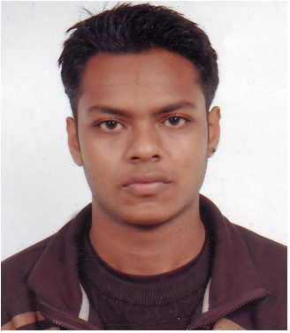
A
Younus Khan

84/2, Badda Jowhashahra 1229, Dhaka Bangladesh.
Email: younus_khan33@yahoo.com, dj_majistic@hotmail.com

Telephone: 01747947398

Objective | To assume challenging and rewarding responsibilities that brings together the highest level of intellectual, logical, communication and computational skills in pursuit of a broad range of interdisciplinary problems, where efficient and reliable solutions to complex problems are rewarded.

Qualification | - “O” Level’s from British Council.  - Diploma from Aptech 2006 on IT Programming and Graphics designing, brought up in U.S.A. in New York City for thirteen years.  - Music production course from JLB records as a Dj in California as disc jogger (DJ). In Bangladesh, I conduct shows in five star hotels and foreign clubs only, and others.

Skills | - Proficient in Microsoft Office packages.  - Familiar with Internet-based software.  - Handling Music based Software, like- Virtual DJ, Apple, iTunes, and many more.

Job Experience | - Worked in Pak Bangla Franchise of (Moody International, UKAS) ISO certifying company as a Marketing Manager & operations in 2003-2004. Task of job was to visit different companies to certify, so that we can provide ISO certificate, before that I had to inspect the company carefully and then I used to give the ISO certificate.  - Worked in the Travel Max travel agency for six months in Probation at 2006 as Marketing, Sales, Ticketing and Reservation, Commutation Executive. Task of job was to visit certain companies to represent the travels and selling tickets and do reservation for the clients and keeping communication with all airlines the travels worked with.  - Worked in Radisson Water Garden Hotel in Sundaree SPA and customer care maintaining, the account and all the shifts for the other workers. Starting date: 02/05/07.  - Worked in IOS Call center as trainer and caller agent 2008-2009.  - Currently working for “Monthly Call Centre” as Business Development Manager, Trainer, and Magazine Editor.  - Currently working on my own Garments related works.

Personal Details | - Father’s Name: Khaled Khan (Late)  - Mother’s Name: Humaira Banu  - Present Address: 84/2, Badda Jowhashahra 1229, Dhaka Bangladesh.  - Date of Birth: October 28, 1986.  - Sex: Male  - Marital Status: Single  - Height: 5 feet 7 inch  - Nationality: Bangladeshi  - Religion: Islam

---------------------------------------------
Younus Khan

